Ideation Phase
Define the Problem Statements

Date | 25-08-2025
Team ID | LTVIP2025TMID61075
Project Name | Book Nest:Where Stories Nestle
Maximum Marks | 2 Marks

Customer Problem Statement
To define the core problems readers face while accessing and discovering books, and use those insights to guide the development of BookNest.

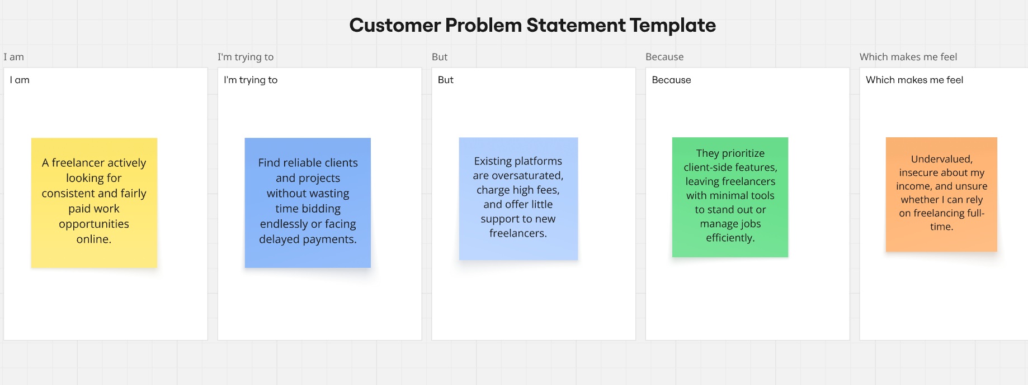

Problem Statement (PS) | I am (Customer) | But | Because | Which makes me feel
PS-1 | a student and avid reader | most books are expensive or unavailable | I can’t buy or borrow as many books as I want | left out, limited, and discouraged from reading more
PS-2 | a working professional who enjoys reading | recommendations online are too generic | platforms don’t personalize suggestions to my taste | overwhelmed and unsatisfied with my reading journey
PS-3 | a parent who wants to build a reading habit in my child | bookstores and apps don’t guide me well | age-based personalized recommendations are missing | confused, frustrated, and less motivated to encourage reading

